**5.9 Quadrilaterals on the Coordinate Plane HW**

1. What type of quadrilateral is *SRQP*? Prove it using a mathematical argument.

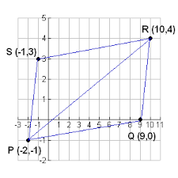

*SRQT* is a ______________________________ because ________________________________  
  
_____________________________________________________________________________

1. What type of quadrilateral is *QRST*? Prove using a mathematical argument

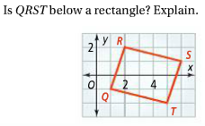

*QRST* is a ______________________________ because ________________________________  
  
_____________________________________________________________________________

1. What type of quadrilateral is *EFGH*? Prove it using a mathematical argument.

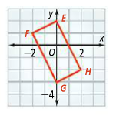

*EFGH* is a ______________________________ because ________________________________  
  
_____________________________________________________________________________

4. What type of quadrilateral is *PQRS* below? Prove it using a mathematical argument.

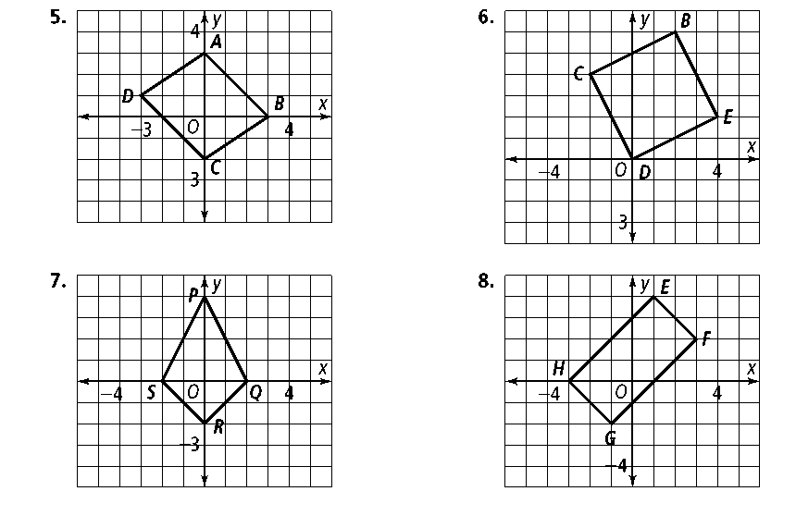

*PQRS* is a ______________________________ because ________________________________  
  
_____________________________________________________________________________

5. What type of quadrilateral is *ABCD* below? Prove it using a mathematical argument.

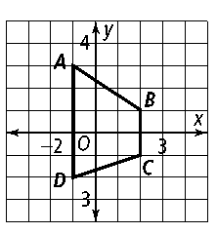

*ABCD* is a ______________________________ because ________________________________  
  
_____________________________________________________________________________

6. What type of quadrilateral is below? Prove it using a mathematical argument.



This is a ______________________________ because ________________________________  
  
_____________________________________________________________________________